

|  |
| --- |
| **Assignment No:** 02  **Submitted To:** Muhammad Javed  **Submitted By:** Mishal Nadeem  **Registration No:** 2023-BS-AI-020  **Subject:** Object Oriented Programming  **Department:** Computer Science |

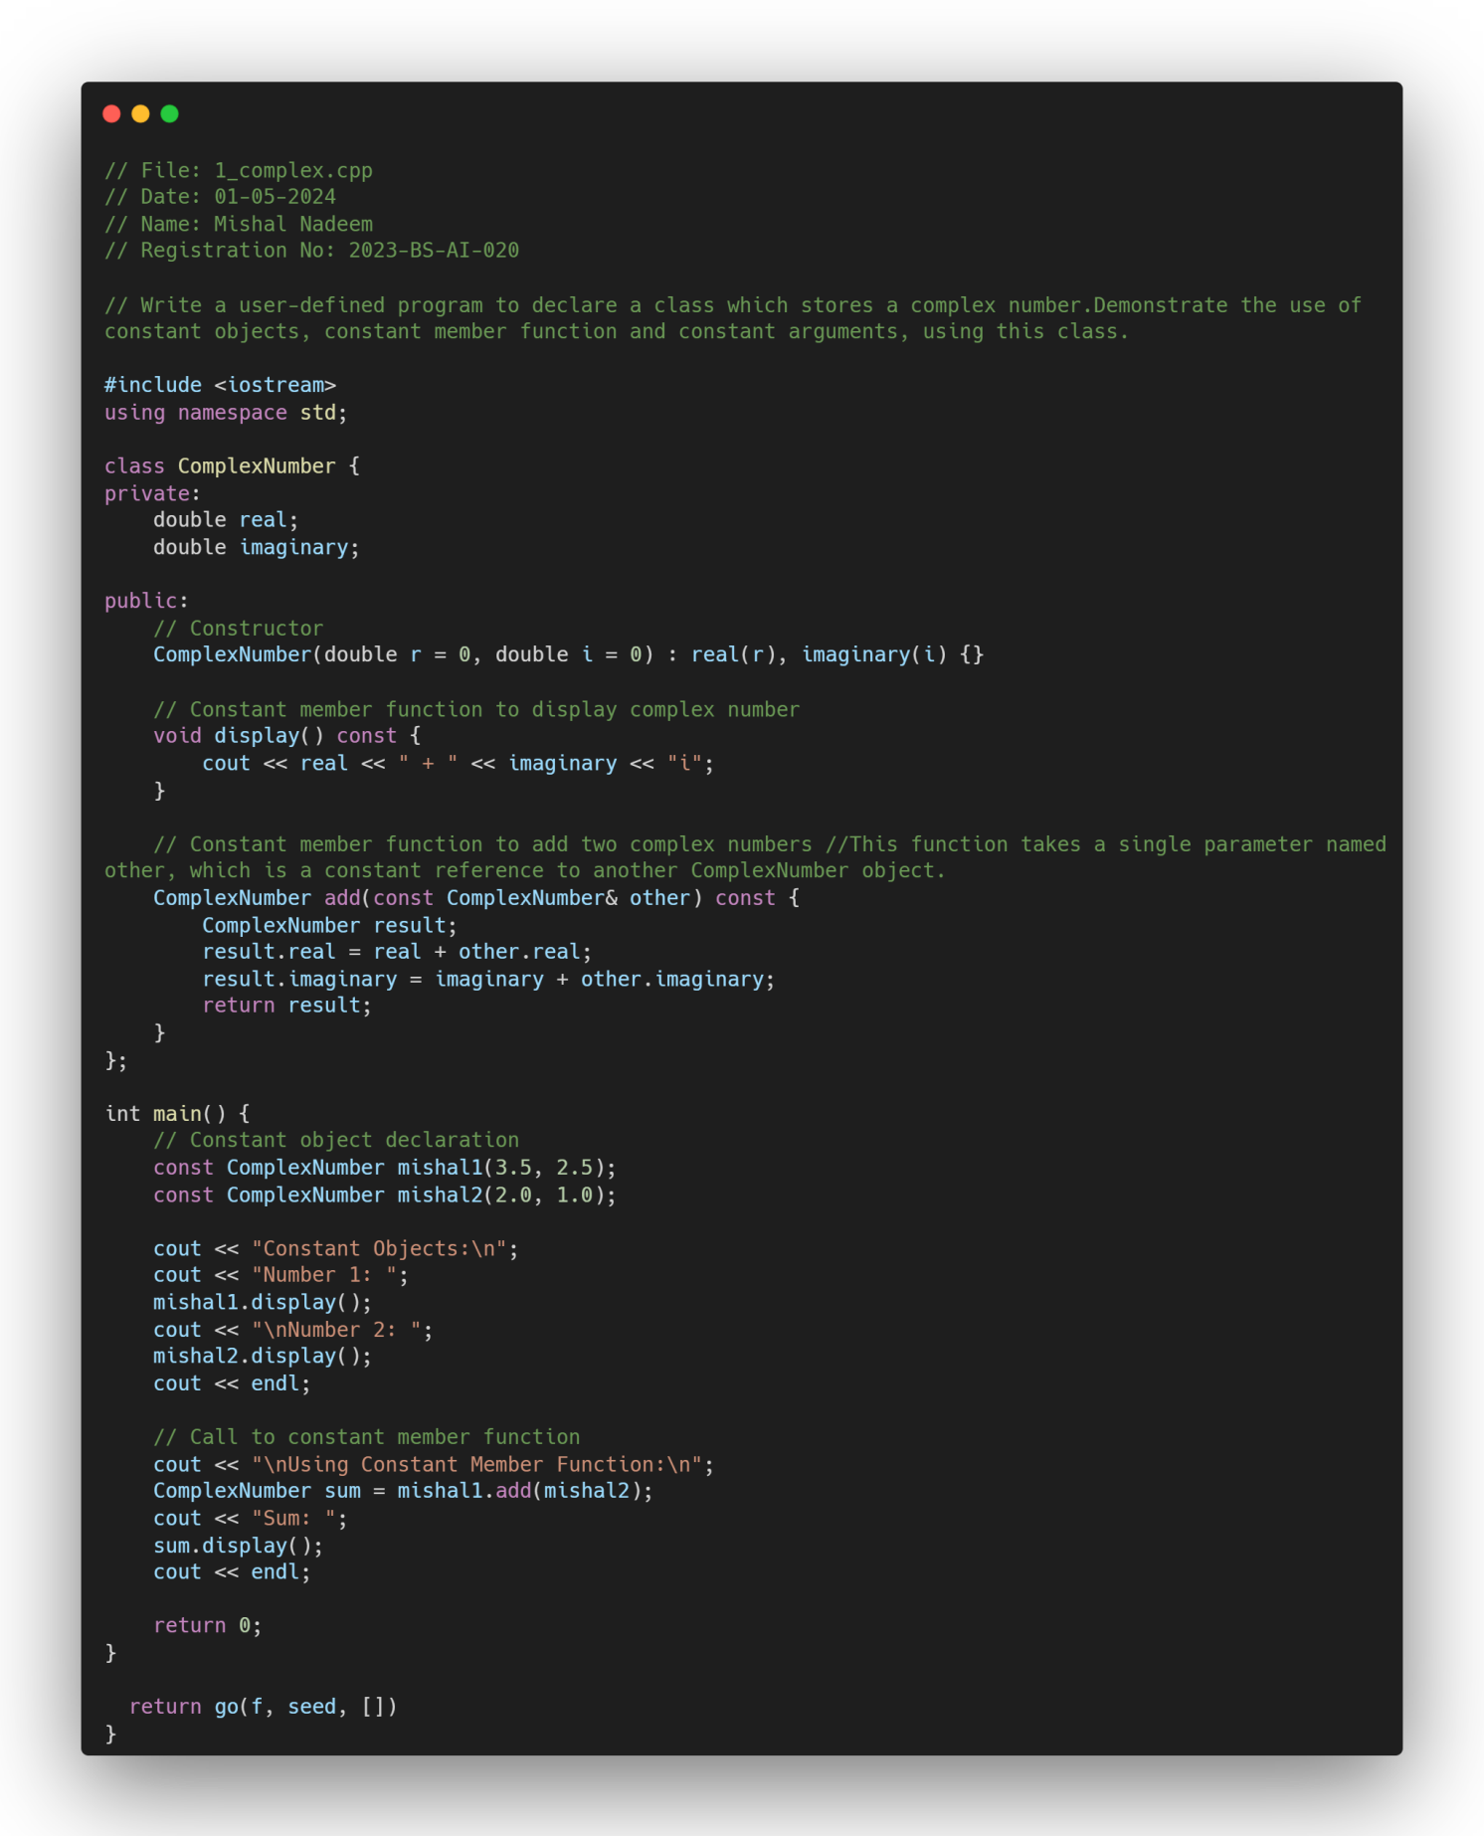 Problem 1

Problem 2

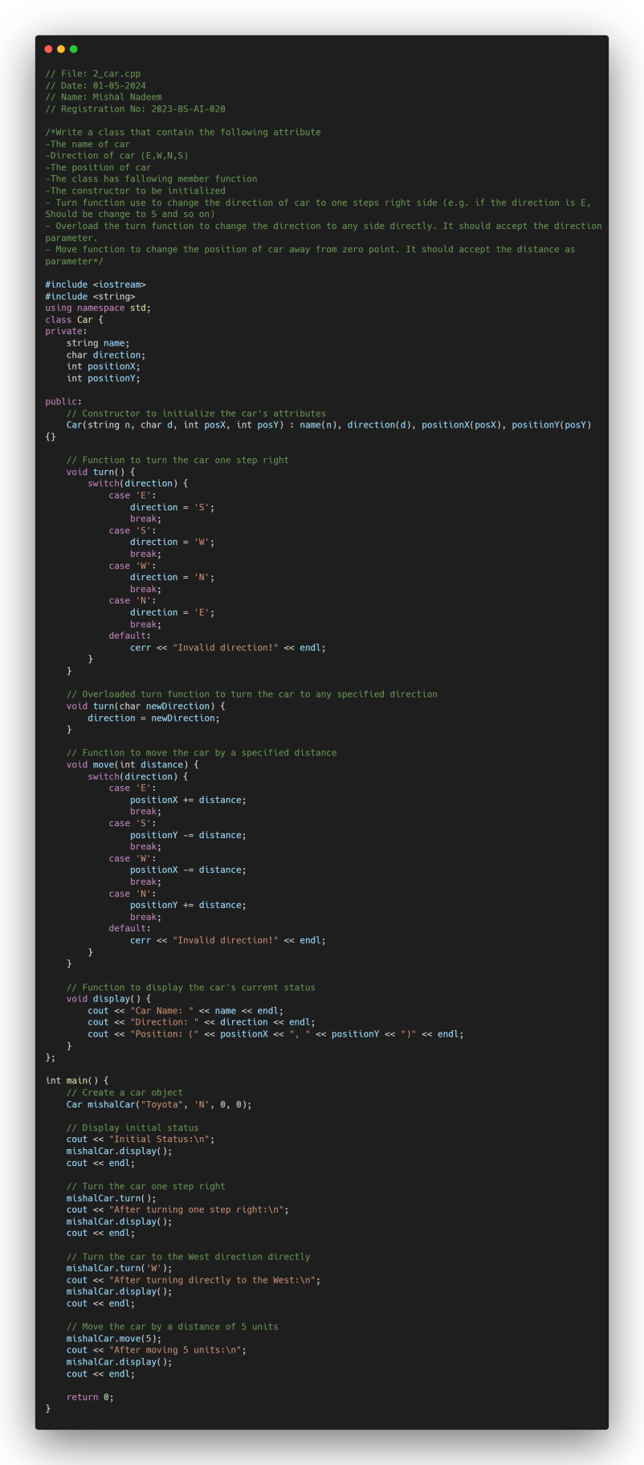

Problem 3

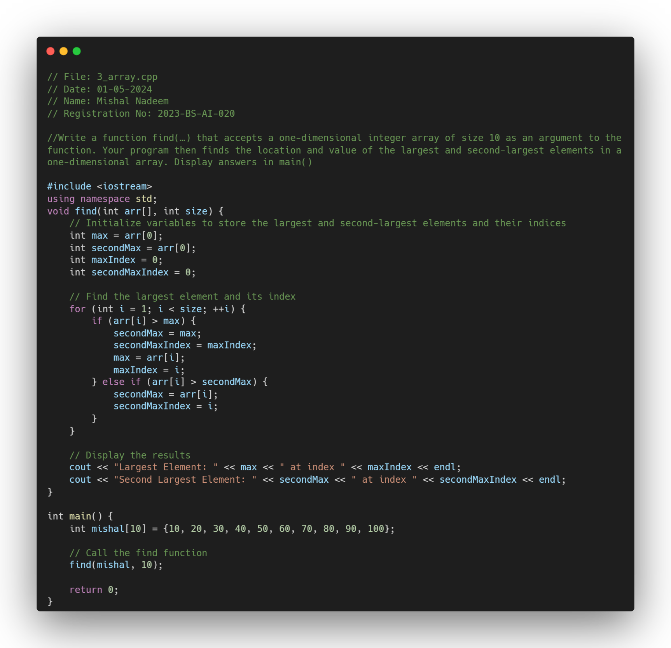

Problem 4

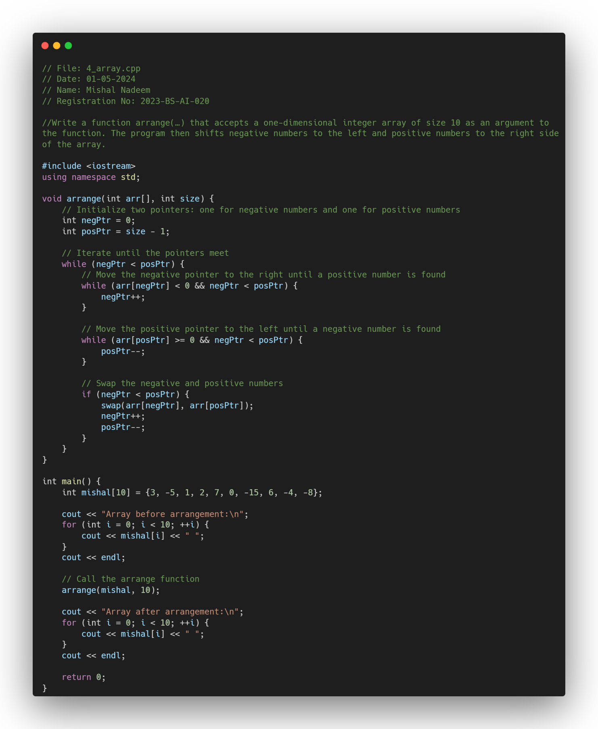

Problem 5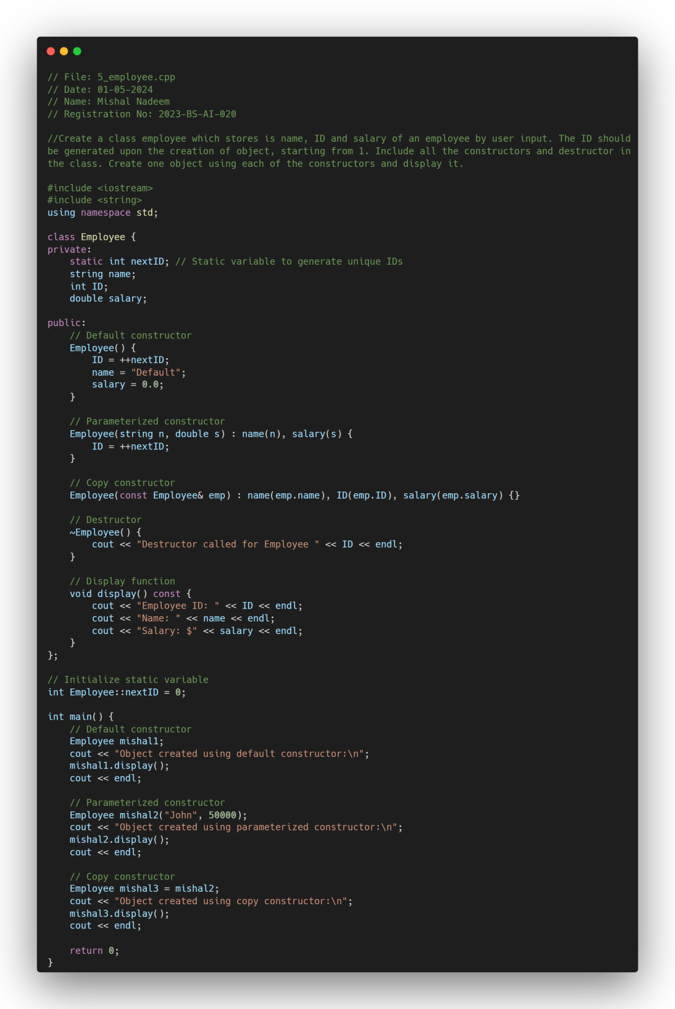

Problem 6

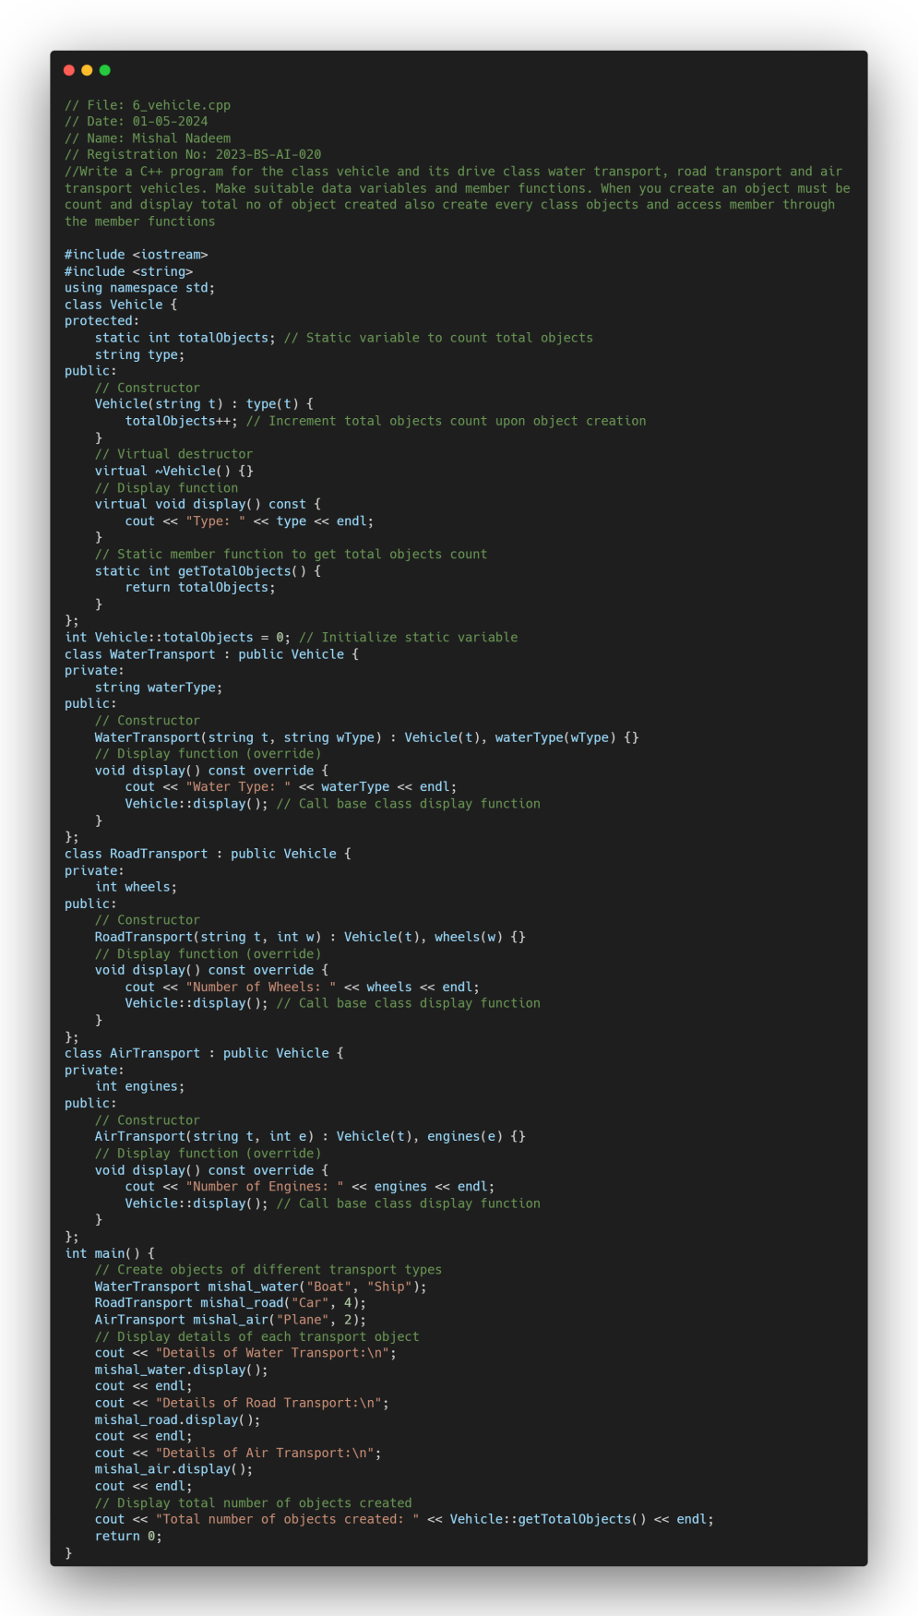

Problem 7

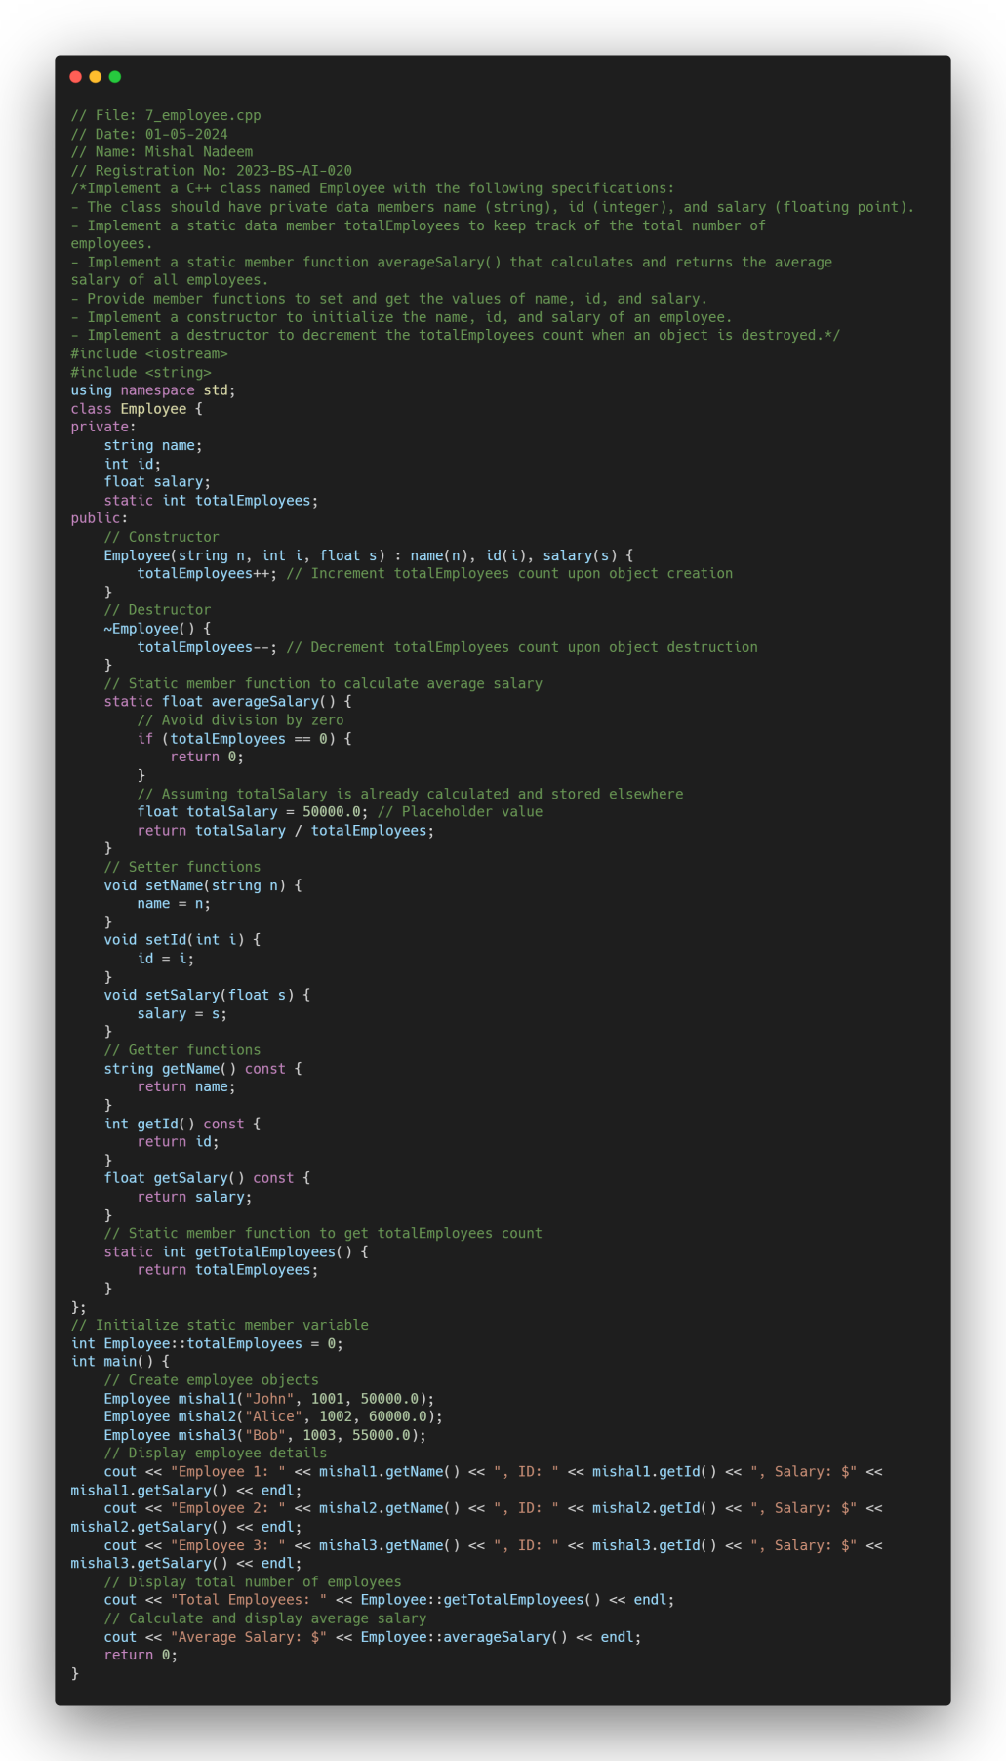

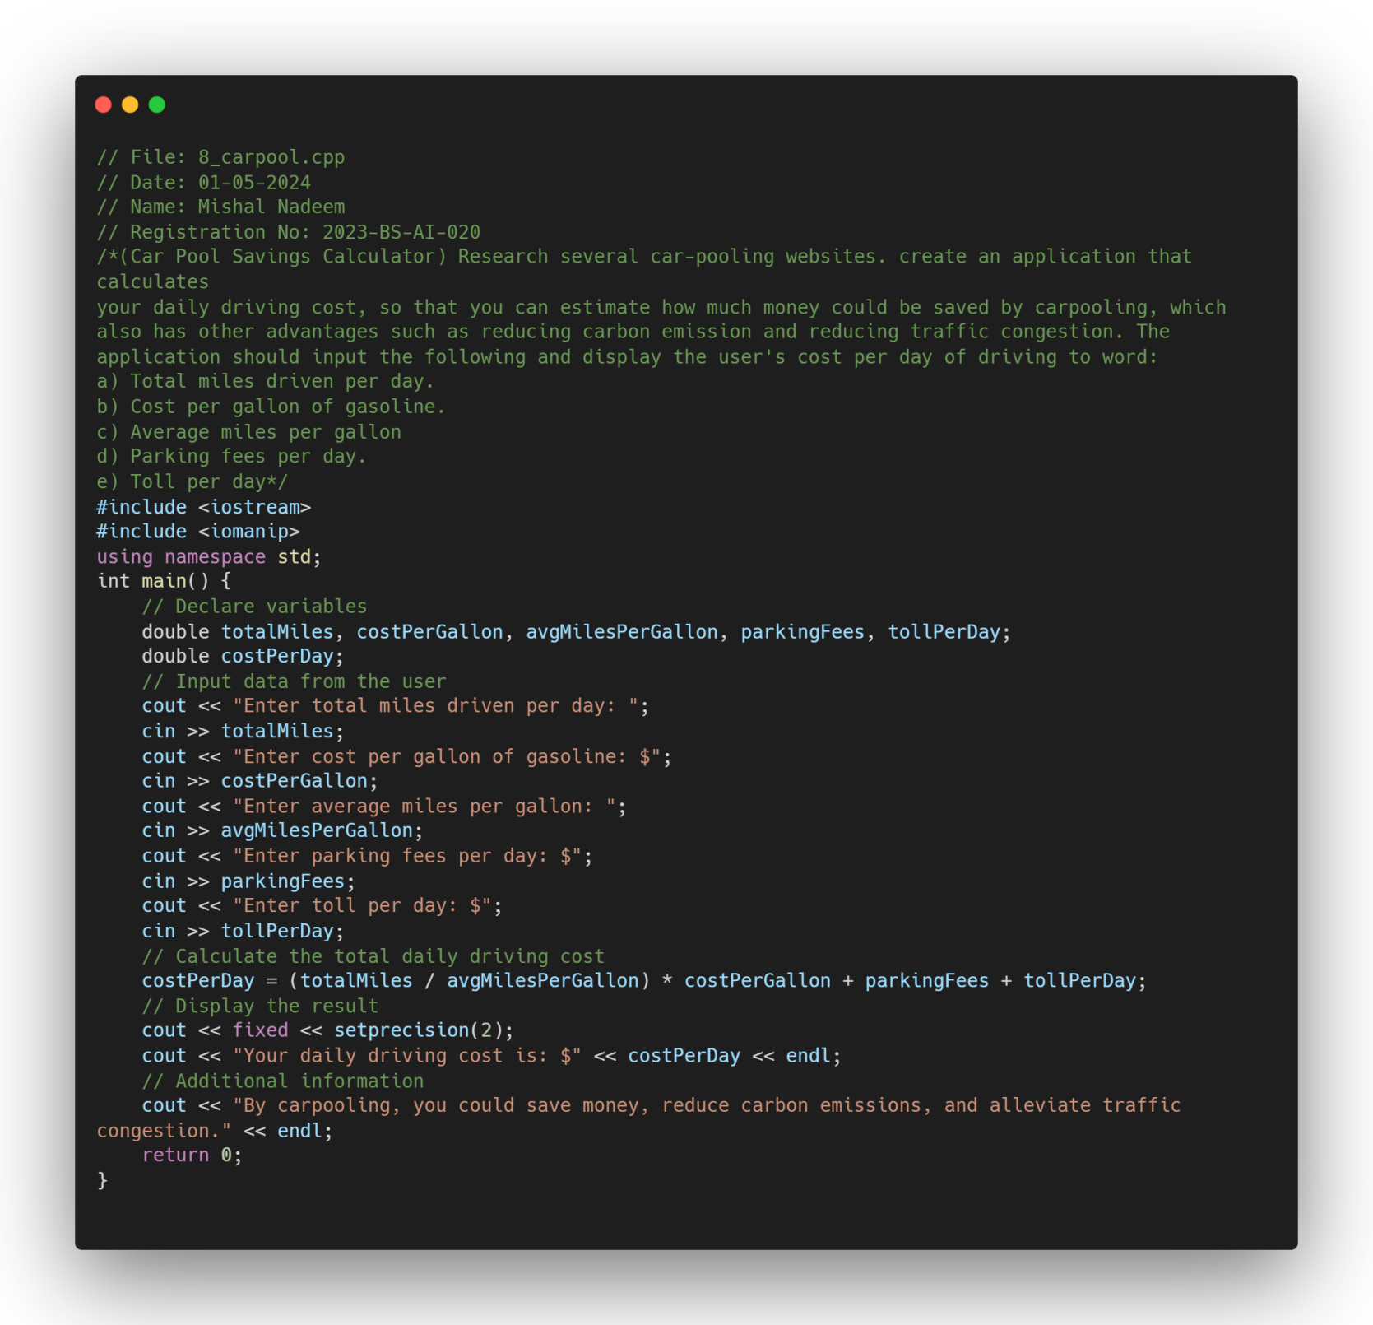 Problem 8